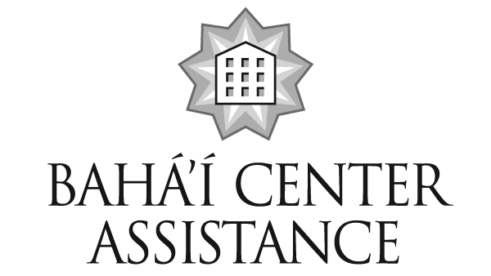
Lessons Learned #4

The Bahá’í Center Assistance Corp. (BCA) is a committee of the National Spiritual Assembly of the Bahá’ís of the United States to support the growth and development of the Faith by providing a systematic program of education, training and technical assistance, and financial assistance to communities whose goal is to lease or purchase and maintain Bahá’í Center Properties.

The article below is one in a series of case studies that present lessons learned from situations that local communities have experienced.

Scenario: After many years of planning, fundraising, hard work, love and sacrifice, a community was almost ready to open their new Bahá’í center and were considering names for it. Some ideas were:

- Naming the center after a prominent Bahá’í
- Naming the center after someone that is deceased
- Naming it the Regional Center of the Bahá’ís of the Greater Bay Area

The Center Planning Committee could not find guidance on the naming of Bahá’í centers. The Planning Committee asked the Local Assembly to contact the BCA for information. BCA requested direction from the National Spiritual Assembly’s Office of Treasurer.

Lessons Learned: The Universal House of Justice allows each National Spiritual Assembly to decide if Bahá’í centers or rooms in them can be named after individuals. In February 2002 the National Spiritual Assembly of the United States decided that a Bahá’í Center may be named only for deceased Bahá’ís who died in good standing.

When selecting a name for the center, consideration must be give to how the Center name will be found in the phone book. Using “Bahá’í” as part of the name helps clarify the use of the Center so that people do not think it is used primarily for something else, such as a yoga center. Putting “Bahá’í” first may be more important than other terms such as “Greater Bay Area Bahá’í Center”. Listing a person’s name may be very confusing to the general public (e.g., “John Smith’s’ Bahá’í Center”).

The National Spiritual Assembly has decided that the word “Regional” may not be included in the name of a Bahá’í center owned by Local Spiritual Assembly. Since Bahá’í owned facilities are owned and operated by the Institution under whose jurisdiction it resides it cannot be viewed as a “regional’ entity and principally serves the needs of those who reside in that community.

More information: Page 5.5 of the Local Bahá’í Centers Technical Assistance Manual, which is available at www.bahaicenterassistance.org and Chapter 9 of Developing Distinctive Baha'i Communities, 2007 edition, available at www.usbnc.org under the heading “NSA Departments”, sub-headings “Assembly Development”, “LSA Guidance & Tools”, provide information about the naming of a Center. Consultations with members of BCA can be arranged by an Assembly or registered group request by emailing info@bahaicenterassistance.org or calling 847-425-7940.

